**Test a Perceptual Phenomenon**

Questions For Investigation

1. What is our independent variable? What is our dependent variable?

**Answer:**

**Independent Variable:** The words used for performing the Stroop effect test.

**Dependent Variable:** The time taken to recognize the word’s color to complete the Stroop test.

2. What is an appropriate set of hypotheses for this task? What kind of statistical test do you expect to perform? Justify your choices.

**Answer:**

**Null Hypothesis (H0):** The population mean for both Congruent and Incongruent test is same.

**H0**: μi=μc (μi - population mean of incongruent values, μc - population mean of congruent values)

**Alternate Hypothesis(HA):** The population mean for the Congruent data test is less than that of Incongruent.

**HA**: μi > μc (μi - population mean of incongruent values, μc - population mean of congruent values)

I will perform the t-test on the sample data as the two sample data is present and the population parameters are unknown. So we can get the t-value and see if it lies inside or outside of the confidence interval to prove the hypothesis test.

The t-test will be one tail test where we will see if the t-value lies below the left of the 95% confidence interval.

The unavailability of population mean and population standard deviation is also a reason to choose the t-test over the z-test.

3. Report some descriptive statistics regarding this dataset. Include at least one measure of central tendency and at least one measure of variability.

**Answer:**

**Sample size** is 24**.**

**Mean:** xbar=∑x/n (where, xbar is sample mean, x is the value and n is the size of sample)

**Congruent Mean**- 14.05

**Incongruent Mean**- 22.02

### Standard Error – Standard deviation/[√n](https://stackoverflow.com/questions/7280224/solving-the-recurrence-relation-tn-%E2%88%9An-t%E2%88%9An-n) = 0.99 [where n is the sample size]

[See the attached spreadsheet for detail data]

4. Provide one or two visualizations that show the distribution of the sample data. Write one or two sentences noting what you observe about the plot or plots.

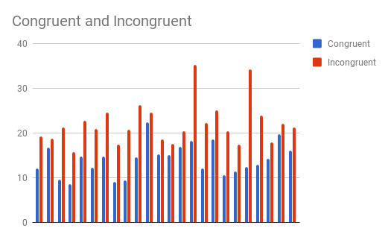

The time taken for incongruent test is greater than that of congruent data test in all sample data provided. The bar graph above shows the plot of congruent v/s incongruent time sample data.

5. Now, perform the statistical test and report your results. What is your confidence level and your critical statistic value? Do you reject the null hypothesis or fail to reject it? Come to a conclusion in terms of the experiment task. Did the results match up with your expectations?

**Answer:**

**t-value:** -8.02

**Confidence interval:** (-8.96, -6.98)

**t-critical:** -2.069

The P-Value is < .00001.  
  
The result is significant at p < .05.

I rejected the null as the t value lies below the t-critical value

Yes the results matched with my expectations.

**Sources used –**

<https://faculty.washington.edu/chudler/java/strvote.html>

Udacity Lectures.

Google Sheets.

http://www.socscistatistics.com/pvalues/tdistribution.aspx